**INTRODUCTION**

**Project Title:** Insight Stream (News App)

**Insight Stream** is a cutting-edge news application designed to simplify how users access, discover, and interact with global and local news. The application offers an intuitive user interface, powerful features, and real-time news updates to keep users informed on various topics such as politics, sports, technology, entertainment, and more.

**Team Members:**

1. Sandhiya.P- TEAM LEADER (Implementation)(sandhiyammu0121@gmail.com)
2. Sangeetha.K - TEAM MEMBER (Implementation)

( sangeethak9719@gmail.com)

1. Sangeetha.S- TEAM MEMBER (Documentation)(sangee0209@gmail.com)
2. Samina Thahira.I.F- TEAM MEMBER (Documentation)(saminathahira@gmail.com)
3. Sandhiya.P.T - TEAM MEMBER (Documentation)(ptsandhiya135@gmail.com)

**Project Overview**

**Purpose:**

Insight Stream aims to provide users with a seamless experience in accessing real-time news and updates from credible sources. Our goal is to offer a user-friendly platform that delivers categorized, searchable, and personalized news content, empowering users to stay informed effortlessly.

**Features:**

* **News API Integration:** Fetch latest and categorized news from trusted sources.
* **Visual News Feed:** Explore news through engaging thumbnails and headlines.
* **Responsive and Intuitive UI:** Simple navigation across categories and news articles.
* **Search Feature:** Find specific news articles with an easy-to-use search bar.
* **Bookmark Articles:** Save favorite news pieces for later reading (future scope).
* **Categorized News:** Explore news through categories like Sports, Technology, Health, Entertainment, Business, and more.

**Architecture**

Insight Stream is designed for a fast, responsive, and seamless news browsing experience. It utilizes **React.js** on the frontend and integrates with third-party News APIs (e.g., NewsAPI.org). The system is modular, highly maintainable, and scalable for future enhancements such as user personalization and AI-based recommendations.

**Component Structure:**

* **App:** Main container for the entire app.
* **Header:** Displays the navigation bar and search bar.
* **Footer:** Contains copyright and social links.
* **Main:** Routing logic and page rendering.
* **NewsList:** Displays lists of news articles.
* **NewsDetail:** Shows detailed news articles.
* **SearchBar:** Search component for querying news.
* **UserProfile (future enhancement):** Displays user info and saved articles.

**State Management:**

Insight Stream uses **React Context API** for global state management, allowing smooth data flow across components without complex prop drilling.

**Routing:**

Utilizes **React Router** to manage navigation:

1. **Installing React Router**

npm install react-router-dom

1. **Routing Configuration (App.js)**

import { BrowserRouter as Router, Routes, Route } from "react-router-dom";

import Navbar from './components/Navbar';

import Home from './pages/Home';

import CategoryPage from './pages/CategoryPage';

import NewsDetail from './pages/NewsDetail';

function App() {

return (

<Router>

<Navbar />

<Routes>

<Route path="/" element={<Home />} />

<Route path="/category/:categoryName" element={<CategoryPage />} />

<Route path="/article/:id" element={<NewsDetail />} />

</Routes>

</Router>

);

}

export default App;

**Setup Instructions**

**Prerequisites:**

To set up and run Insight Stream, ensure the following tools are installed on your system:

* **Node.js**: Latest version (LTS or higher)
* **npm**: Node Package Manager (comes with Node.js)
* **Git**: Version control system

**Installation:**

1. Clone the Repository:

git clone https://github.com/[username]/insight-stream.git

1. Navigate to the Project Directory:

cd insight-stream

1. Install Dependencies:

npm install

1. Configure Environment Variables: Create a .env file in the project root directory and add:

REACT_APP_API_URL=https://newsapi.org/v2

REACT_APP_API_KEY=YOUR_API_KEY

(Note: Replace YOUR_API_KEY with an actual News API key from [https://newsapi.org](https://newsapi.org/))

1. Start the Application:

npm start

1. Running the App: Visit:

http://localhost:3000

You should see the **Insight Stream** homepage with the latest news displayed.

**Folder Structure**

The project is structured into three main folders:

* **Pages Folder:** Contains different pages (e.g., Home, CategoryPage, NewsDetail).
* **Components Folder:** Contains reusable components (e.g., Navbar, Footer, SearchBar, NewsCard).
* **Styles Folder:** Contains CSS files for styling and responsiveness.

**Clients:**

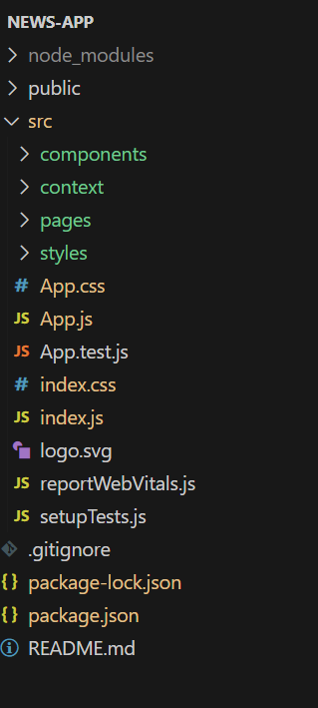 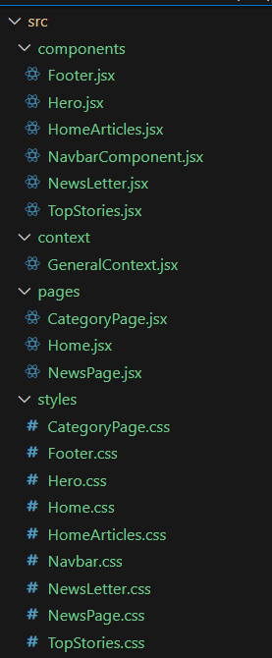

**Component Documentation**

1. **Navbar Component** - Navigation across the application.
2. **Hero Component** - Main banner introducing the app.
3. **Category Page Component** - Displays categorized news.
4. **News Detail Component** - Shows in-depth news articles.
5. **Search Bar Component** - Allows users to search for articles.
6. **Button Component** - Customizable button used throughout the app.
7. **Card Component** - Displays news articles in a card format.

**State Management**

* **Global State:** Managed using React Context API for seamless data flow.
* **Local State:** Managed using the useState and useEffect hooks for handling user interactions and API requests.

Example (React Context API for Theme Management):

import React, { createContext, useState, useContext } from 'react';

const ThemeContext = createContext();

export function ThemeProvider({ children }) {

const [theme, setTheme] = useState("light");

return (

<ThemeContext.Provider value={{ theme, setTheme }}>

{children}

</ThemeContext.Provider>

);

}

function App() {

const { theme, setTheme } = useContext(ThemeContext);

return (

<div className={theme}>

<button onClick={() => setTheme(theme === "light" ? "dark" : "light")}>Toggle Theme</button>

</div>

);

}

**Project Execution:**

Here are some of the screenshots of the application.

* **Hero components**

In the hero component, the trending news articles are displayed. It is to highlight them. Apart from that, the search bar is also available to search for various articles and categories.

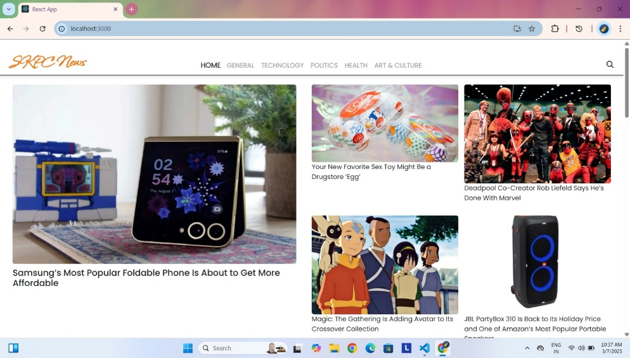

* **Popular categories**

In the hero component, the trending news articles are displayed. It is to highlight them. Apart from that, the search bar is also available to search for various articles and categories.

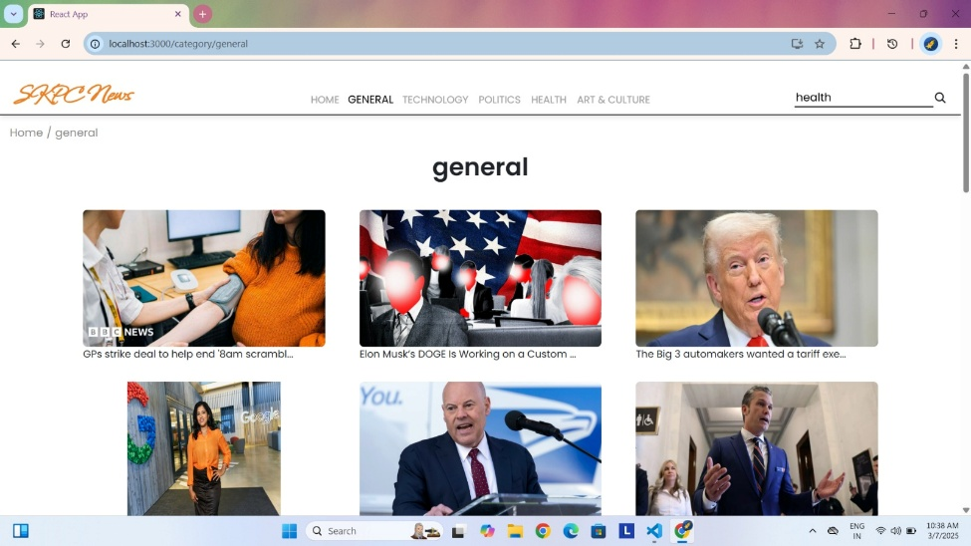

* **Newsletter**

Staying informed is key! This section would act as a magnet for users who want to stay up-to-date on the latest news. A brief signup form with an email field would be presented, along with a clear call to action button like "Subscribe Now" or "Get Daily News Updates." With a simple click, users can join the InsightStream community and receive curated news delivered straight to their inbox.

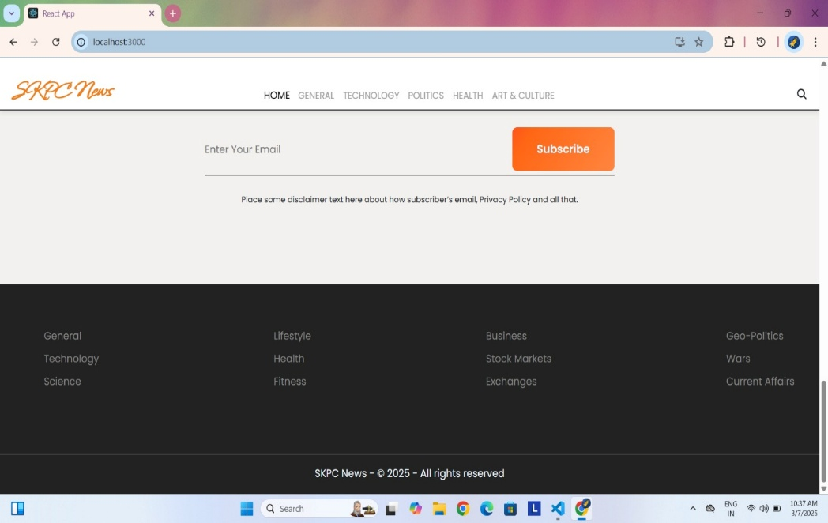

* **Category/Search result page**

Finding the news you crave is effortless with InsightStream. This page displays a neatly organized list of articles matching your chosen category or specific search query. Each entry would provide a clear headline, a concise summary, and if available, an image to give you a quick glimpse into the story. To further refine your exploration, filters or sorting options might be available. Imagine narrowing down results by date, source, keyword, or other relevant criteria to pinpoint exactly what you're looking for.

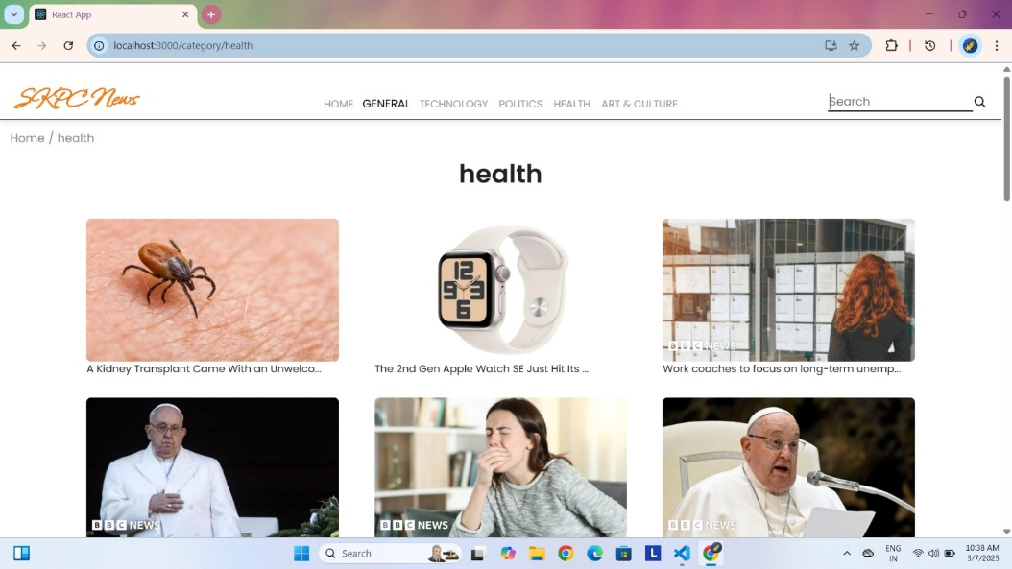

* **Redirected Article page**

This is where you dive deep! The article page proudly displays the complete news story, retrieved directly from the original source. To keep you engaged and exploring related topics, the page might also suggest additional articles based on the current story. These suggestions can open doors to a world of interconnected information, allowing you to become a well-rounded news connoisseur.

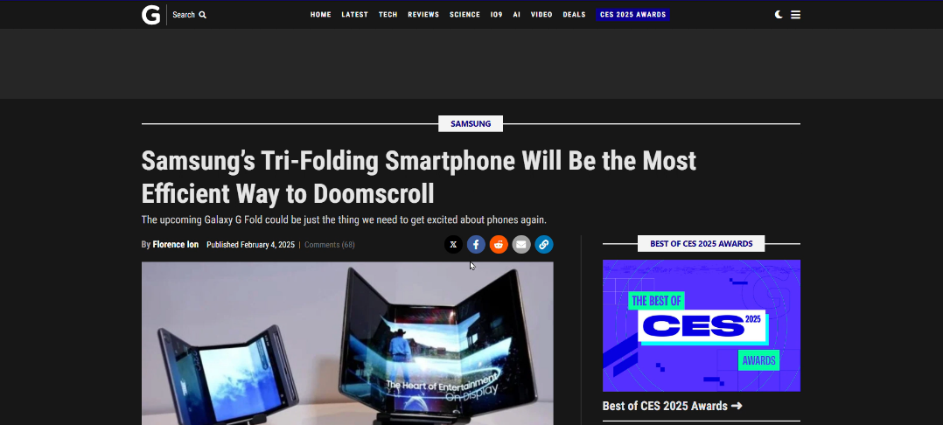

**Project Demo link:**

<https://drive.google.com/drive/folders/1ZVdRTEx-sNw5-z5rzXKLHK1wkNcNa-1P?usp=drive_link>

**Future Enhancements**

* **AI-Based Recommendations:** Personalized news suggestions.
* **User Authentication:** Enable login/signup features.
* **Bookmark Feature:** Allow users to save news articles.
* **Push Notifications:** Real-time updates on breaking news.
* **Mobile App Development:** Expand to Android & iOS.